Burkina Faso National Child Project under the Africa Minigrids Program (AMP)
Annex 13 – GHG Emissions Reductions and Project’s target contributions to GEF-7 Core Indicators

Introduction

A financial model has been developed during the PPG Phase (the AMP Financial Model) the main objective of which is to take a standardized approach at analyzing minigrid pilots which will receive support from national child projects and provide revised estimations for the projects’ target contributions to GEF-7 Core Indicators to replace those developed during the PFD Phase. Box 1 presents the indicators AMP projects report on.

Box 1: AMP & GEF-7 Core Indicators
AMP projects contribute to the following GEF-7 Core Indicators:

- Core indicator 6: Greenhouse Gas Emissions Mitigated captures the amount of GHG emissions expected to be avoided through the GEF project’s investment in renewable energy minigrids. It should be measured above a baseline value. Mitigation benefits include:
  - Direct emissions reductions attributable to the investments made during the project's supervised implementation period, totaled over the respective lifetime of the investments. For national child projects under AMP, direct emission mitigation arises from minigrid pilot investments under Component 2.
  - Indirect emissions reductions that could result from a broader adoption of the outcomes of a GEF project plus longer-term emission reductions from behavioral change in the post-project period. Broader adoption of a GEF project proceeds through several processes including sustaining, mainstreaming, replication, scaling-up and market change. For national child projects under AMP, direct emission mitigation results from creating a general enabled investment environment for minigrid market development, and subsequent investment flows.

- Context Sub-indicator 6.4: Increase in installed renewable energy capacity per technology captures the increase in renewable energy generation or storage capacity and should be disaggregate by type of renewable energy technology (biomass, geothermal, ocean, small hydro, solar photovoltaic, solar thermal, wind power, and storage). All AMP national child projects will be contributing to the increase of solar photovoltaic and/or storage capacity.

- Core indicator 11: Number of direct beneficiaries disaggregated by gender as co-benefit of GEF investment captures the total number of direct beneficiaries including the proportion of women beneficiaries. Direct beneficiaries are all individuals receiving targeted support from a given project. For AMP national child projects this refers to the investments in minigrids projects under Component 2. AMP national child projects will be reporting on this indicator disaggregated by customer segment. Box x below provide additional details on this.

For the purpose of estimating greenhouse gas (GHG) emissions reductions (ER), assumptions are made in terms of what level of concessionality is applied to the use of GEF INV funds to support minigrid pilots (defined in terms of a percentage of capital expenditure costs (CAPEX) to be covered by GEG INV hereinafter referred to as ‘CAPEX subsidy levels’.

The AMP Financial Model takes a different approach at estimating CAPEX subsidy levels than the one used at PIF stage. This approach results in a level of subsidy which is a function of the difference in the levelized cost of electricity (LCOE) between the clean energy minigrid and a notional diesel-only minigrid. As such, the model estimates for each of the minigrid pilots, the LCOE of the renewable energy minigrid and of a diesel-only minigrid serving an equivalent market, and the resulting level of subsidy (as a % of CAPEX) required to make the renewable energy minigrid LCOE equal to that of the diesel-only minigrid. LCOEs and subsidy levels are indicative and meant only for the purpose of updating greenhouse gas (GHG) emissions reductions (ER) at the PPG Phase.

At PIF stage, it was assumed that all minigrid pilots would be greenfield minigrid projects and only residential customers of these minigrids were considered as direct beneficiaries of the project. The PPG Phase has provided more nuance as to the types of minigrid pilots that will receive Program support and their respective direct beneficiaries. The former include the following three types of minigrid pilots: (1) Greenfield minigrids, (2) Hybridization of existing or planned diesel minigrids, and (3) A productive use overlay to an existing or planned minigrid; and the latter are described in Box 2 below.

Box 2: Project (Pilot) beneficiaries
AMP national child projects will be reporting on the number of people who are ‘direct beneficiaries’ of the project. As per GEF’s definition, direct beneficiaries are all individuals receiving targeted support from a given project, and targeted support is the intentional and direct assistance of a project to individuals or groups of individuals who are aware that they are receiving that support and/or who use the specific resources.

In the context of AMP, only minigrid customers gaining access to electricity and/or improved electricity services are considered direct beneficiaries of the project. Those community members who benefit from accessing goods and services enabled by electricity, are considered indirect beneficiaries. The exact definition of direct beneficiaries for each type of pilot is presented below.

Type of pilot | Targeted support provided by the project | Direct beneficiaries
Greenfield | Providing access to clean/reliable/affordable electricity to new minigrid users through development of new minigrid sites | All new minigrid customers
Hybridization | Providing improved electricity services to all existing as well as new users of an existing minigrid, based on a larger share of renewable energy and a clear path for diesel phase-out | All existing as well as new customers of the hybridized minigrid
PUE Overlay | Providing improved electricity services to all existing as well as new users of an existing minigrid through the addition of productive use equipment for use by Commercial/PUE users, which improves sustainability of the minigrid for all its customers | All existing as well as new customers of the minigrid to which a PUE Overlay is added

Project direct beneficiaries are categorized in three different customer segments as show in the table below.

Customer Segment | AMP - Program-level definition | # people per minigrid connection
Residential (households) | All households connected to a minigrid regardless of whether they use electricity in the household for value-adding activities. | 5 people (household residents)
Social  (community and public institutions) | Churches, community centers, health facilities, educational facilities, street lighting, government buildings, and public buildings. | 4 people (employees)
Commercial/PUE  (productive users of electricity) | Customers who are engaged in value-adding activities powered/enabled by electricity, who in turn provide goods and services to indirect project beneficiaries. Commercial loads such as lighting, cooking, information and communication, refrigeration, space heating/cooling, and motive power are used for value-adding activities such as restaurants, shops, sewing services, beauty salons, internet-cafes, as well as transformation processes, like rice milling, usually embedded in agricultural supply chains. | 3 people (owners, employees)

This annex contains the results and calculations of project contributions to GEF-7 Core Indicators, describes the pilots that will be developed under the project to contribute to these results, and the methodologies used to estimate direct Greenhouse Gas (GHG) emissions reductions (ER) expected at CEO Endorsement Request. To that end, it is structured as follows:

- Section II – Executive Summary presents a snapshot of project results and contributions to GEF-7 Core indicators and a comparison with same calculations at PFD/PIF stage
- Section III – Minigrid Investment Pilots describes the type of pilot that the Burkina Faso National Child Project will provide support for
- Section IV - AMP Financial Model Calculations & Methodology presents the calculations for the pilot(s) and describes inputs and methodology used

Executive Summary - Project Results

The Burkina Faso National Child Project aims to support deployment of several minigrid pilots in the country, and these minigrid pilots would be of one of these 2 types (i) Greenfield Solar PV-battery minigrids to bring access to clean and affordable electricity to a previously unserved rural community, with lower operating costs and GHG emissions than a comparable (notional) diesel-only minigrid and (ii) Productive use overlay to existing Solar PV-battery minigrids, to increase capacity utilization factor of these existing minigrids, reduce their LCOE and increase optimal usage of existing minigrid assets. Section III describes the pilots in more detail.

The following table shows the project’s updated target contributions to GEF-7 Core Indicators as estimated at the time of CEO endorsement request submission and compares them with those targets included in the Program Framework Document (PFD) and the Burkina Faso Project Concept approved by the GEF Council in December 2019.

Table 1: Project Results – Expected at PIF and at CEO Endorsement
Project GEF-7 Core Indicators |  | Expected at PIF | Expected at CEO Endorsement
6 | Greenhouse Gas Emissions Mitigated (metric tons of CO2e) | 3,700 (direct)  727,037 (indirect top-down) | 14,353 (direct)  495,000 (indirect)
6.4 | Increase in installed renewable energy capacity per technology (MW) | 0.09 (solar PV) | 0.40728 (solar PV)  0.99993 (storage)
11 | Number of direct beneficiaries disaggregated by gender (and customer segment) as co-benefit of GEF investment (number of people) | 15,074 (of which 50% women) | 5,564 people (of which 50% women)  --------  5,310 people (residential)  85 people (social)  169 people (commercial/PUE)  5,564 people (total)  --------  1,062 connections (residential)  21 connections (commercial)  21 connections (social)  35 connections (productive use)  1,816 connections (total)

The exact number of minigrids to be deployed and the estimated number of households, commercial, social, and productive use customers that will be served by each of these minigrids during this project’s implementation is currently unknown. It has been estimated that based on the financial models developed, (i) 10.62 greenfield Solar PV minigrids, each of capacity 20 kWp, 50 kWh, can be supported under this project, for the purpose of estimating GHG emissions reductions, based on an indicative total budget allocation (Pilot 1) of USD 350,000; and (ii) 6.09 PUE overlay of existing Solar PV minigrids can be supported under this project, for the purpose of estimating GHG emissions reductions, based on an indicative total budget allocation (Pilot 2) of USD 327,350. Section III describes the pilots in more detail.

The table below shows these results disaggregated for each of the 10.62 greenfield Solar PV-battery minigrid individual pilot (Pilot 1) and each of the 6.09 PUE overlay of existing Solar PV-battery minigrid individual pilot (Pilot 2) under the project.

Table 2: Project Results - Burkina Faso National Project under the Africa Minigrids Program (AMP)
Project GEF-7 Core Indicators |  | Pilot 1 | Pilot 2
6 | Greenhouse Gas Emissions Mitigated (metric tons of CO2e) | 1,033 (direct) | 555 (direct)
6.4 | Increase in installed renewable energy capacity per technology (kW – solar) (kWh - storage) | 20 (solar PV)  50 (storage) | 32 (solar PV - incremental)  77 (storage – incremental)
11 | Number of direct beneficiaries disaggregated by gender (and customer segment) as co-benefit of GEF investment (number of people) | 517 people  ---------  500 people (residential)  8 people (social)  9 people (commercial/PUE)  517 people (total)  ---------  100 connections (residential)  2 connections (commercial)  2 connections (social)  1 connections (productive use)  105 connections (total) | 12 people (incremental)  -----------  00 people (residential)  00 people (social)  12 people (commercial/PUE)  12 people (total)  ---------  0 connections (residential)  0 connections (commercial)  0 connections (social)  4 connections (productive use)  4 connections (total)

Indicative Minigrid Systems

Various aspects of these pilots remain to be defined during project implementation (e.g. CAPEX subsidy levels, estimated number of households, commercial, social, and/or commercial/PUE customers that will be served by each of these minigrids). Hence, for the purpose of estimating an indicative subsidy requirement and indicative GHG emissions reductions, the financial models for each of these proposed (several) minigrid pilots simulate the following 2 types of representative, standardized minigrid system profiles (Indicative minigrid systems).

It is important to note that the indicative minigrid system simulated by this financial model has been built to oversize the system capacity and CAPEX upfront to have enough electricity generation, storage and distribution capacity to meet demand growth from local communities for up to 10 years. This approach has been adopted to ensure overall GHG ER estimates are easier to make during this modeling stage. However, AMP aims to support developers to optimize their minigrid system designs and hence, this approach of oversizing may not be relevant for actual pilot deployment during implementation stage and does not constitute any recommendation in terms of the appropriate sizing of the pilots’ minigrid systems.

The following are the characteristics of each of the Indicative greenfield minigrid system (Pilot 1):

- The minigrid would serve 100 residential customers, 2 social customers (1 school, 1 healthcare clinic), 2 ‘smaller’ load commercial/PUE customers (1 restaurant, 1 shop) and 1 ‘larger’ load commercial/PUE customer (1 rice/corn mill).
- Based on assumptions for estimated electricity demand from each of these customers over a 20-year period, the financial model estimated a baseline notional, diesel-only minigrid of capacity 12.64 kW/15.8 kVA) to serve these customers.
- An indicative greenfield minigrid system with Solar PV of capacity 20 kWp and a battery of capacity 5050 kWh is modelled to be deployed to serve the same set of customers. No diesel genset backup is modelled.
- The capital expenditures (CAPEX) required to setup this minigrid system are estimated at USD 71,634 based on an average CAPEX cost of USD 3,508 per kW of installed solar PV capacity.
- Th Levelized Cost of Energy (LCOE) of this indicative 20 kWp 50 kWh greenfield Solar PV-battery minigrid system is estimated at $1.52/kWh whereas the LCOE of the baseline notional 12.64 kW diesel-only minigrid system is estimated at of $0.94/kWh.
- To achieve LCOE parity between the baseline notional diesel-only minigrid system and the hybridized Solar PV-battery-diesel system, the financial model estimates a CAPEX subsidy of approximately USD 32,952 per minigrid (Pilot 1 type), or 46% of CAPEX, would be necessary.

The following are the estimated results at CEO ER stage of proposed greenfield minigrid pilots (Pilot 1 type) receiving support from the Burkina Faso National Child Project assuming that all greenfield Solar PV-battery minigrids that will be deployed under this project will conform to the characteristics describe above:

- With the allocated INV budget of USD 350,000 for all greenfield minigrid pilots (Pilot 1 type) under this project, and assuming that this entire amount will be used as capital expenditures (CAPEX) subsidy for minigrid investment pilot(s), it is estimated that a total of 10.62 greenfield Solar PV-battery minigrids can be supported under this project.
- The number of direct project beneficiaries (GEF Core indicator 11) is expected to be around 5,491 people. Assuming the customer load profile of the Indicative greenfield minigrid system (Pilot 1 type) applies to each of the likely 10.62 minigrids to be deployed, this project can provide support for 1,115 new minigrid customer connections to solar-battery minigrid systems (1,062 residential, 21 social, and 32 commercial/PUE).
- The increase in renewable energy capacity installed is estimated at 20 kWp for solar PV and the increase in storage capacity is estimated at 50 kWh per greenfield solar-battery minigrid (Pilot 1 type) deployed. Hence, for 10.62 greenfield solar-battery minigrids (Pilot 1 type) deployed under this project the total increase in renewable energy capacity installed is estimated at 212.4 kWp (0.2124 MW) for solar PV and the increase in storage capacity is estimated at 531 kWh (0.531 MWh).
- The lifetime global environmental benefits that will accrue from the adoption of off-grid solar technologies is estimated at 10,973 tCO2e (due to 10.62 greenfield solar-battery minigrid pilots (Pilot 1 type) deployed under this project). This is calculated for the 20-year period of the technology’s lifetime.
- The project yields an abatement cost of 90 USD/tCO2e. for greenfield solar PV battery minigrid (Pilot 1 type). This abatement cost takes into consideration overall upfront and replacement CAPEX of such pilots.

The following are the characteristics of each of the Indicative minigrid system that would take the productive use overlay approach (Pilot 2):

- Pilot 2 will use a Productive Use Overlay approach to optimize an existing minigrid which is already serving 175 households, 2 social users (1 school, 1 healthcare clinic), and 4 ‘smaller’ load commercial/PUE customers (2 restaurants, 2 shops) and 1 ‘larger’ load commercial/PUE customer (1 rice/corn mill) by adding productive users and productive use equipment.
- Based on assumptions for estimated electricity demand from each of these customers over a 20-year period, the financial model estimated a baseline minigrid system (without additional PUE overlay) with Solar PV capacity of 35 kWp and battery capacity of 86 kWh to serve these customers. No diesel genset backup is modelled.
- Since the exact number and power load of PUE equipment to be overlayed on this existing minigrid is currently unknown, for the purpose of LCOE estimation and GHG emission reduction calculation, we estimate 4 new PUE equipment – 1 submersible water pump, 1 sewing machine, 1 cold storage unit, 1 welding and carpentry equipment will be overlayed on existing Solar PV-battery minigrid.
- Based on assumptions for estimated electricity demand from each of the existing 175 households, 2 social users (1 school, 1 healthcare clinic), and 4 ‘smaller’ load commercial/PUE customers (2 restaurants, 2 shops) and 1 ‘larger’ load commercial/PUE customer (1 rice/corn mill) and the newly proposed 4 PUE overlay customers over a 20-year period, the financial model estimated a minigrid system with Solar PV capacity 67 kWp and battery capacity of 163 kWh to serve these customers. No diesel genset backup is modelled.
- This Levelized Cost of Energy (LCOE) of the indicative baseline 35 kWp 86 kWh Solar PV-battery minigrid system is estimated at $1.55/kWh whereas the LCOE of the indicative 67 kWp 163 kWh Solar PV-battery minigrid system with PUE overlay is estimated at of $1.42/kWh, thereby achieving the desired result of reduced LCOE due to improved capacity utilization factor.
- For the purpose of this financial modeling exercise of PUE overlay Pilot 2 type, a subsidy amount is envisaged to be provided for increased capex of Solar PV-battery minigrid system due to PUE overlay as well as capex of 4 newly proposed PUE equipment to be overlayed, since the incremental Solar PV-battery capacity and PUE overlay equipment are proposed to be procured and deployed as ‘containerized box’ system. The incremental capex of this incremental Solar PV-battery system and PUE equipment to be overlayed is estimated to be US$ 105,356.
- In order to estimate the level of subsidy required for this incremental Solar PV-battery capacity and PUE equipment to be overlayed, the subsidy level required by the baseline existing 35 kWp 86 kWh Solar PV-battery minigrid to have the same LCOE as a notional diesel-only minigrid system serving the same number of existing customers (without PUE overlay) is computed, and it is estimated to be 51% of upfront CAPEX. Using the same 51% subsidy level for the capex of incremental Solar PV-battery capacity and PUE equipment to be overlayed (containerized box system), it is estimated that each PUE Overlay type minigrid intervention (Pilot 2 type) requires a subsidy amount of US$ 53,732.

The following are the estimated results at CEO ER stage of the proposed PUE overlay of existing Solar PV-battery minigrid pilots (Pilot 2 type) receiving support from the Burkina Faso National Child Project assuming that all PUE overlay of existing Solar PV-battery minigrids that will be deployed under this project will conform to the characteristics describe above:

- With the allocated INV budget of USD 327,350 for all PUE overlay minigrid pilots (Pilot 2 type) under this project, and assuming that this entire amount will be used as capital expenditures (CAPEX) subsidy for PUE overlay minigrid investment pilot(s), it is estimated that a total of 6.09 PUE overlay of existing Solar PV-battery minigrids (Pilot 2 type) can be supported under this project.
- The number of incremental direct project beneficiaries (GEF Core indicator 11) is expected to be around 73 people. Assuming the incremental PUE overlay customer load profile of the Indicative PUE overlay of existing Solar PV-battery minigrid system (Pilot 2 type) applies to each of the likely 6.09 minigrids to be deployed, this project can provide support for 24 new minigrid customer connections to solar-battery minigrid systems (24 new commercial/PUE).
- The increase in renewable energy capacity installed is estimated at 194.88 kWp for solar PV and the increase in storage capacity is estimated at 468.93 kWh.
- The lifetime global environmental benefits that will accrue from the adoption of off-grid solar technologies is estimated at 3,380 tCO2e (due to 6.09 PUE overlay of existing solar-battery minigrid pilots (Pilot 2 type) deployed under this project). This is calculated for the 20-year period of the technology’s lifetime.
- The project yields an incremental abatement cost of 32 USD/tCO2e. for PUE overlay of existing solar PV battery minigrid (Pilot 2 type). This abatement cost takes into consideration overall upfront and replacement CAPEX of such pilots.

Overall, for all pilots to be supported under this Burkina Faso National Child Project (10.62 greenfield Solar PV-battery minigrids (Pilot 1 type) and 6.09 PUE overlay of existing solar PV-battery minigrids (Pilot 2 type):

- The lifetime global environmental benefits that will accrue from the adoption of off-grid solar technologies is estimated at 14,353 tCO2e (10,973 tCO2e due to 10.62 Pilot 1 type pilots and 3,380 tCO2e due to 6.09 Pilot 2 type pilots). This is calculated for the 20-year period of the technology’s lifetime.
- Indirect emission reductions amounting to 495,000 tCO2e are expected due to investments in minigrids completed during the 10-year influence period following project completion, predominantly through the replication of the sustainable technology value chain.
- The project yields an abatement cost of 122 USD/tCO2e (90 USD/tCO2e due to Pilot 1 type pilots and 32 USD /tCO2e due to Pilot 2 type pilots). This abatement cost takes into consideration overall upfront and replacement CAPEX of both pilots.

Comparison with respect to PIF Stage – Direct GHG ER

At PIF stage, it was estimated that US$208,027 would be used to provide CAPEX subsidies to cover 80% of the CAPEX needed to develop 2.52 greenfield minigrid sites at an average investment cost of US$3,450 per kW of installed solar capacity. Each of these minigrid sites was assumed to have 30 kW of installed solar capacity and serve a population of 6,000 people per minigrid (200 people per kW of installed capacity). Hence the total increased RE capacity expected from the project was estimated at 80-90 kW and the number of project direct beneficiaries at 15,074 people, resulting in direct GHG ER of 3.7 ktonCO2e over the technology's lifetime of 20 years.

At CEO ER stage, it is estimated that out of the US$ 677,350 GEF ‘INV’ budget under Component 2: (i) USD 350,000 will be used to provide 46% CAPEX subsidy for the proposed 10.62 greenfield Solar PV-battery minigrids of Pilot 1 type based on an average investment cost of US$3,508 per kW of installed solar capacity (ii) USD 327,350 will be used to provide 51% CAPEX subsidy for proposed PUE overlay of 24 new productive use equipment for existing 6.09 Solar PV-battery minigrids of Pilot 2 type. Assumptions on the number of people served by each minigrid have been revised downward with respect to PIF stage; the number of direct project beneficiaries from both pilots together is expected to be around 5,564 people. This is due to the project’s support for the connection of 5,310 residential users (1,062 new household connections, each household assumed to have 5 people), 85 social users (21 new social connections), and 96 new commercial/PUE users (32 new commercial/PUE connections) under 10.62 Pilot 1 type minigrids and 73 new commercial/PUE users (24 new commercial/PUE connections) under 6.09 Pilot 2 type minigrids(13.66 people per kW of installed capacity).

The table below compares key parameters used to determine project’s results at PIF and CEO endorsement request stages.

Parameters to estimate project results | PIF Stage | At CEO Endorsement
Type of pilot | Greenfield minigrid | Pilot 1 – Greenfield minigrid  Pilot 2 – PUE Overlay of existing Minigrid
GEF INV used as CAPEX subsidy (USD) | 208,027 | 677,350
Subsidy level | 80% | Pilot 1 – 46% for greenfield minigrid types (10.62 minigrids)  Pilot 2 - 51% for incremental Solar PV-battery capacity and PUE equipment CAPEX
# minigrids | 2.52 | 16.71
Minigrid installed solar PV capacity (kW/minigrid) | 30 | 20 – Pilot 1 type each  32 – Pilot 2 type each (incremental)
Minigrid battery storage capacity (kWh/minigrid) | Not defined | 50 – Pilot 1 type each  77 – Pilot 2 type each (incremental)
CAPEX per kW of installed solar capacity (USD/kW) | 3,450 | 3,508 – Pilot 1 type  2,980 – Pilot 2 type (incremental)
Number of people per unit of installed solar PV capacity (people per kW) | 200 | 13.66
Number of people served by minigrid (people/minigrid) | 6,000 | 5,491 – Pilot 1 type minigrids  73 – Pilot 2 type minigrids
Annual RE generation (MWh/year/minigrid) | 95 | 190 – Pilot 1 type minigrids  169.15 - Pilot 2 type minigrids
Emission factor of diesel-only minigrid (tCO2/MWh) | 0.786 | UNFCCC methodology (refer Section IV)
Minigrid annual GHG ER (tCO2/year/minigrid) | 74 | Pilot 1 Type Minigrids– 549  Pilot 2 Type Minigrids – 171  Total Project – 720
Project annual GHG ER (tCO2/year) | 186.8 | Pilot 1 Type Minigrids- 10,973  Pilot 2 Type Minigrids – 3,380  Total Project – 14,353

At PIF stage, power generation per minigrid was estimated at 94.61 MWh per year, considering a 40% solar capacity factor (fraction of installed solar PV capacity that can effectively generate electricity) and a 90% availability factor (fraction of time the minigrid system is online and available to generate power during a given year). Based on annual generation, the comparison with a diesel only minigrid (with an emission factor of 0.786 tons CO2e/MWh), yields annual project GHG ER of 74 metric tons of CO2e resulting in direct GHG ER of 186.8 tCO2e over the technology's lifetime of 20 years.

At CEO ER stage, power generation per minigrid is estimated at 190 MWh per year for Pilot 1 type minigrids and 169.15 MWh per year for Pilot 2. Based on annual generation, the comparison between the 10.62 greenfield Solar PV-battery minigrids and a notional diesel only minigrid (Pilot 1 type) and comparison between the existing 6.09 Solar PV-battery minigrids with and without PUE Overlay (Pilot 2 type), yields annual project GHG ER of 720 metric tons of CO2e (549 tCO2e for Pilot 1 type minigrids and 171 tCO2e for Pilot 2 type minigrids). Hence the total direct GHG ER over 20 years for the project is now estimated at 14,353 tons of CO2e (10,973 tCO2e for Pilot 1 type minigrids and 3,380 tCO2e for Pilot 2 type minigrids).

Comparison with respect to PIF Stage – Indirect GHG ER

Indirect emissions mitigation at PIF stage was estimated at 727,037 tCO2e. This was done using a top-down approach, on the basis that the project contributes to an enabled environment which subsequently attracts investment in renewable energy minigrids adding approximately 41 MW of installed capacity over a 10-year post-project period. Indirect emissions mitigation from these minigrids is calculated over their technology lifetime of 20 years. The methodology assumes that minigrids will electrify either 33%, 20% or 15% (in this case 15%) of the unelectrified population (13,579,178 people). The selection of this minigrid electrification factor was based on several criteria, including (1) current levels of grid coverage; (2) recent and ongoing initiatives for grid extension; (3) geographical size of countries; and (4) spread of off-grid communities in terms of population density. Thereafter the methodology applies a causality factor varying between 20% and 80%, chosen based on the state of the minigrid market development and ongoing baseline initiatives in each country; for this project it was estimated at 40%.

A similar methodology has been applied at CEO ER stage to revise estimations of indirect GHG ER arising from renewable energy minigrid investments expected to occur over a 10-year post-project period, enabled in part by project contributions. Emissions mitigation at CEO ER stage has been estimated at 495,000 tCO2e as a result of renewable generation capacity additions of 44.2 MW. The methodology assumes that minigrids will electrify either 30%, 20% or 15% (in this case 15%) of the rural unelectrified population (14,721,221 people). It also assumes a causality factor of 40% to estimate what percentage of GHG ER can be attributed to enabling conditions to which the project has contributed.

Parameters to estimate indirect GHG ER | PIF Stage | At CEO Endorsement
Unelectrified population (million people) | 13,579,178 | 16,907,314
National electrification rate (%) | 25% | 14%
Unelectrified rural population (people) | NA | 14,721,221
Minigrids Total Electrification factor (% of total unelectrified population) | 15% | 15%
Minigrids Rural Electrification factor (% of unelectrified rural population) | NA | NA
Number of people to be electrified by minigrids (people) | 2,036,877 | 2,208,183
Average minigrid market size (# households/minigrid) | 100 | 100
Average minigrid system size (kW per minigrid) | 10 | 10
Number of people per unit of installed solar PV capacity (people per kW) | 50 | 50
Installed RE capacity over post-project 10-year period (MW) | 41 | 44.2
Causality factor (attribution to AMP) (%) | 40% | 40%

Burkina Faso - Minigrid Investment Pilots

The Burkina Faso National Child Project will support an indicative number of 10.62 minigrid investment pilots of greenfield Solar PV-battery minigrids (Pilot 1 type), and an indicative number of 6.09 minigrid investment pilots of PUE overlay of existing Solar PV-battery minigrid (Pilot 2 type), each of them based on a minigrid system (a representative standardized minigrid system) which is briefly described below:

- Pilot 1 will develop a Greenfield Solar Battery minigrid.
  - Pilot 1 type is estimated to be a greenfield Solar PV-battery minigrid that would serve 100 residential customers, 2 social customers (1 school, 1 healthcare clinic), 2 ‘smaller’ load commercial/PUE customers (1 restaurant, 1 shops) and 1 ‘larger’ load commercial/PUE customers (1 rice/corn mill)
  - It is estimated that project will be adding 20 kWp of installed solar capacity and 50 kWh of battery storage.

The allocated GEF project INV budget of USD 350,000 for Pilot 1 will be used to provide 46% CAPEX subsidy for the proposed greenfield 10.62 Solar PV-battery minigrid pilots, with each pilot conforming to the indicative minigrid pilot profile described above.

- Pilot 2 will use a Productive Use Overlay approach
  - Pilot 2 will be an existing minigrid system (already consisting of 175 households, 2 social users (1 school, 1 healthcare clinic), and 4 ‘smaller’ load commercial/PUE customers (2 restaurants, 2 shops) and 1 ‘larger’ load commercial/PUE customer (1 rice/corn mill) upon which the project will add a PUE Overlay.
  - It is to be noted that the minigrid systems upon which the project will add a PUE Overlay, are already installed. The 35kWp, 86 kWh (average capacity) solar PV-battery systems were developed for several ecovillages of Burkina Faso by the Ministry of Environment and Climate Change through the Ecovillage Initiative.
  - However, the average demand for electricity from the existing connected users has increased in these villages. Additional villages have also shown interest in connecting with this project. Therefore, with new and increased load profiles the financial model considers investments in additional solar-battery installed capacity which also improves the utilization of the existing solar PV-battery system.
  - Pilot 2 type is estimated to overlay 4 more PUE connections for each minigrid of this type – 4 PUE equipment to be overlayed, with the incremental Solar PV-battery capacity and PUE overlay equipment proposed to be procured and deployed as ‘containerized box’ systems on existing Solar PV-battery minigrids.

The allocated GEF project INV budget of USD 327,350 for Pilot 2 will be used to provide 51% CAPEX subsidy for the proposed 6.09 PUE overlay of existing Solar PV-battery minigrid pilots, with each pilot conforming to the indicative minigrid pilot profile described above.

The table below provides a brief description of each pilot, the allocated budget and the expected increase in renewable energy (RE) capacity.

Table 3:Burkina Fasoi National Child Project – Minigrid investment pilots
Pilot Summary
Pilot # / name | Pilot 1.  Community Solar Energy Platforms (CSEP) | Pilot 2.  PUE Overlay | Combined
Type of Pilot | Greenfield MG with a focus on productive use | Productive use overlay to an existing MG
Objective: | The CSEP project aims at providing access to modern electricity and productive equipment to households, micro-businesses and rural cooperatives, enabling the development of new productive activities, increasing the economic competitiveness of rural populations, improving the efficiency of agri-food processing, and reducing greenhouse gas emissions | This pilot aims to increase energy access through Productive Uses in the Ecovillages of Burkina Faso
Technology: | Solar PV + Battery | Solar PV + Battery
Total number of minigrids | 10.62 | 6.09
Budget Allocated (USD) (estimated CAPEX subsidy): | $350,000 | $327,350 | $677,350
Use of GEF INV funds | Provide CAPEX subsidies for 46% of the cost of the greenfield minigrid system. | Provide CAPEX subsidies for 51% of incremental Solar PV + Battery capacity and PUE equipment to be overlayed on existing Solar PV-battery minigrid system.
System Sizing & Increase in RE Capacity
Pilot # | Pilot 1 | Pilot 2 | Combined
Solar PV Capacity (kWp) | 0 (existing)  212.4 (required) | 213.15 (existing)  408.03 (required) | 213.15 (existing)  620.43 (required)
Solar PV Capacity (kWp) | 212.4 (Incremental) | 194.88 (Incremental) | 407.28 (incremental)
Battery Capacity (kWh) | 0 (existing)  531 (required) | 523.74 (existing)  992.67 (required) | 523.74 (existing)  1523.67 (required)
Battery Capacity (kWh) | 531 (Incremental) | 468.93 (incremental) | 999.93 (incremental)

The following table shows the number of new user connections by customer segment and the resulting number of direct beneficiaries for each pilot and the project.

Table 4: Burkina Faso National Child Project – New minigrid connections and direct beneficiaries
Existing and New Minigrid Connections
Pilot # / name | Pilot 1 (Greenfield Minigrid) Type (10.62 Minigrids) | Pilot 2 (PUE Overlay to an Existing Minigrid) Type (6.09 Minigrids) |  | Combined/Project
Customer segment | New users | Existing users | New users | New users
Residential | 1,062 | 1,066 | 0 | 1,062
Social | 11 (Healthcare Clinics)  10 (Schools)  21 (total) | 6 (Hospitals)  6 (Schools)  12 (total) | 0 | 11 (Healthcare Clinics)  10 (Schools)  21 (total)
Commercial | 11 (Restaurant/eatery)  10 (Shop)  21 (total) | 12 (Restaurant/eatery)  12 (Shop)  24 (total) | 0 (total) | 11 (Restaurant/eatery)  10 (Shop)  21 (total)
Productive users | 11 (Rice/Corn Mill)  11 (total) | 6 (Rice/Corn Mill)  6 (total) | 6 (Submersible Water Pump)  6 (Sewing Machine)  6 (Cold Storage Units)  6 (Welding and Carpentry equipment)  24 (total) | 11 (Rice/Corn Mill)  6 (Submersible Water Pump)  6 (Sewing Machine)  6 (Cold Storage Units)  6 (Welding and Carpentry equipment)  35 (total)
Total connections | 1,115 | 1,108 | 24 | 1,139
Pilot direct beneficiaries | 5,491 | 5,468 | 73 | 5,564

AMP Financial Model Calculations & Methodology

Findings/highlights/conclusions for Burkina Faso Pilot 1.

- Co-financing is key for Pilot 1 type (indicative greenfield solar battery minigrid systems) to reach financial close and deliver the intended results. GEF INV budget allocated to pilot 1 covers a fraction of the CAPEX costs for Pilot 1, and a fraction of the estimated subsidy contribution that would be required to reach LCOE parity with respect to a diesel-only baseline. Although the level of CAPEX subsidy will be defined in each case during project implementation by the respective Implementing Partner, it’s worth noting that co-financing (as committed by the various areas / spheres of Burkina Faso’s Government) will be critical to put the required infrastructure in place for the community that has been identified.
- Estimated LCOE for the proposed indicative greenfield solar-battery minigrid system is higher than LCOE of a comparable diesel-only minigrid system. The financial modeling exercise of proposed 20 kWp 50 kWh greenfield solar-battery minigrid system estimated an LCOE of $1.52/kWh when compared to an LCOE of $0.94/kWh of a comparable (notional) diesel-only minigrid system.
- Subsidy of 46% of upfront capex would reduce LCOE of indicative greenfield solar-battery system to be equal to that of comparable notional diesel-only minigrid system. The financial modeling exercise of proposed 20 kWp 50 kWh greenfield solar-battery minigrid system estimated an LCOE of $0.94/kWh with a 46% subsidy for upfront capex which is almost equal to an LCOE of $0.94/kWh of a comparable (notional) diesel-only minigrid system.
- Annual and Lifetime Carbon Emission Savings. The financial modeling exercise of proposed indicative 20 kWp 50 kWh greenfield solar-battery minigrid system estimated an annual carbon emission reduction of 52 tCO2e and a lifetime (20-year) carbon emission reduction of 1,033 tCO2e when compared to a comparable (notional) diesel-only minigrid system. For 10.62 such greenfield solar PV battery minigrid systems, annual carbon emission reduction of 549 tCO2e and a lifetime (20-year) carbon emission reduction of 10,973 tCO2e when compared to baseline diesel-only minigrid systems.
- Lifetime Carbon Abatement Costs. The financial modeling exercise of proposed 20 kWp 50 kWh greenfield solar-battery minigrid system estimated a lifetime carbon abatement costs (lifetime capex divided by lifetime carbon emission savings) of $90 when compared to a comparable (notional) diesel-only minigrid system.

Methodology and calculations – Pilot 1

Step 1 – Defining Indicative minigrid system characteristics.

- The model simulates an indicative greenfield Solar PV-battery MG system for a custom sized minigrid demand/market.
- Customized demand metrics and typical average load profiles of various customer types are provided to the model as inputs, and an optimized indicative Solar PV-battery system size configuration is computed by the model (proposed to be deployed under this GEF project).
- In this case, each of the proposed 10.62 the minigrid would serve 100 residential customers, 2 social customers (1 school, 1 healthcare clinic), 2 ‘smaller’ load commercial/PUE customers (1 restaurant, 1 shop) and 1 ‘larger’ load commercial/PUE customer (1 rice/corn mill). Based on assumptions for estimated electricity demand from each of these customers over a 20-year period, the financial model estimated a baseline notional, diesel-only minigrid of capacity 12.64 kW/15.8 kVA to serve these customers. An indicative greenfield minigrid system with an indicative Solar PV of capacity 20 kWp and a battery of capacity 50 kWh is modelled to be deployed to serve the same set of customers. No diesel genset backup is modelled.

Step 2 – Estimating LCOE and subsidy levels.

- The model uses a combination of generic and country-specific inputs to estimate the all-in costs for the minigrid including capital expenditures (CAPEX), operational and maintenance costs (OPEX) and financing costs.
- The model calculates the Levelized Cost of Electricity (LCOE) without PUE overlay of an indicative greenfield minigrid system, that is the price that would have to be charged for the electricity to be able to recover all costs (CAPEX, OPEX and financing costs) over a 20-year period timeframe.
- The model compares the LCOEs of proposed greenfield 20 kWp 50 kWh Solar PV-battery minigrid with that of a notional 12.64 kW/15.8 kVA diesel-only minigrid system modelled in the financial model.
- To achieve LCOE parity of a comparable notional diesel-only minigrid (with a diesel genset of 12.64 kW/15.8 kVA capacity), a subsidy of 46% of upfront capex is necessary for the greenfield Solar Battery minigrid system as shown in the figure below.

Figure 1: Subsidy Level for LCOE Parity – Burkina Faso Pilot 1
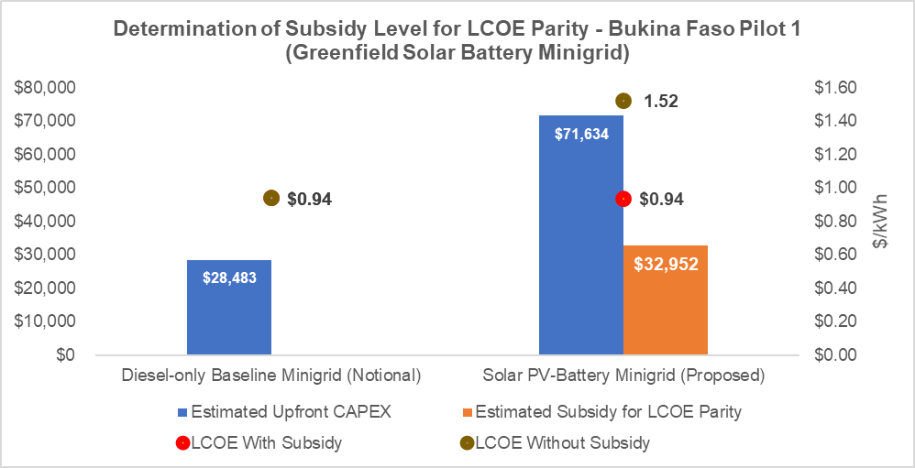

Step 3 – Estimating GHG ER for indicative minigrid system.

- The model estimates environmental benefits for the proposed greenfield Solar PV-battery minigrid system by comparing the GHG emitted between the Program scenario (greenfield Solar PV-Battery minigrid system deployed) and baseline scenario (notional diesel-only minigrid system deployed).
- Estimation of GHG emissions avoided is based on estimating CO2 emissions reduction using emission factors for various consumer types as per AMS-III.BB: Electrification of Communities through grid extension or construction of new minigrids.
- The Figure below shows the GHG emission reductions due to deployment of an indicative greenfield Solar PV-Battery Minigrid (Pilot 1 type) system. The direct GHG emissions reductions from proposed indicative greenfield Solar PV-battery minigrid system estimated an annual carbon emission reduction of 52 tCO2e. Also, estimated a lifetime (20-year) carbon emission reduction of 1,033 tCO2e over a 20-year lifetime. For 10.62 such greenfield solar PV battery minigrid systems, annual carbon emission reduction of 549 tCO2e and a lifetime (20-year) carbon emission reduction of 10,973 tCO2e when compared to baseline diesel-only minigrid systems. The project yields a GEF abatement cost of 90 USD/tCO2e.

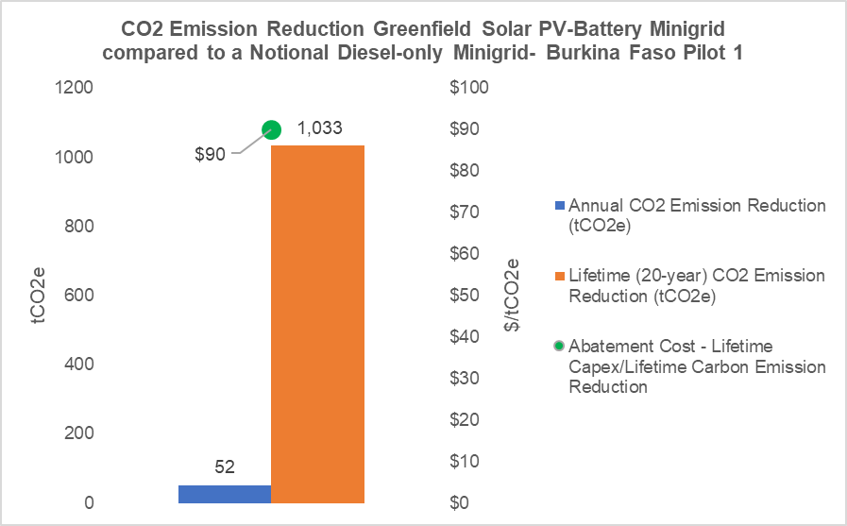
Figure 2: Annual and Lifetime CO2 Emission Reduction (tCO2e) for Greenfield Solar PV Minigrid compared to a notional Diesel-only Minigrid – Burkina Faso Pilot 1

Findings/highlights/conclusions for Burkina Faso Pilot 2.

- Existing indicative minigrids falls short of capacity for new PUE connections. The existing minigrid system upon which the project will add a PUE overlay is undersized therefore additional investments are needed to increase installed capacity (solar, storage) to accommodate PUE overlay. USD 327,350 INV budget under Component 2 for this pilot will be used to provide 51% CAPEX subsidy for proposed incremental Solar PV-battery capacity and PUE equipment overlay of 4 new productive use equipment for each of the 6.09 existing Solar PV-battery minigrids of Pilot 2 type.
- PUE overlay will improve LCOE. The proposed PUE overlay over this existing minigrid system will improve its capacity utilization factor and therefore also decrease the estimated Levelized Cost of Energy (LCOE) of this minigrid system from $1.55/kWh without PUE overlay to $1.42/kWh with PUE overlay.
- Subsidy of up to 51% of upfront capex of incremental Solar PV-battery capacity and PUE equipment to be overlayed (containerized box system) for each of the 6.09 PUE overlay pilots (Pilot 2 type), estimated to be a total of US$ 327,350, is proposed. The financial modeling exercise of the existing indicative Solar PV-battery minigrid considers 51% of upfront capex of incremental Solar PV-battery capacity and PUE equipment CAPEX to be subsidized with GEF project budget.
- PUE overlay will increase annual and lifetime carbon emission savings. The proposed PUE overlay over this existing minigrid system will improve its capacity utilization factor and therefore also increase the lifetime carbon emission savings from this minigrid system. The financial modeling exercise of the existing indicative Solar PV-battery minigrid system estimated an annual carbon emission reduction of 90 tCO2e without PUE overlay and 118 tCO2e with PUE overlay, thereby achieving an effective GHG emission reduction of 28 tCO2e per annum for each of the 6.09 PUE Overlay pilots (Pilot 2 type). The modeling exercise also estimated a lifetime (20-year) carbon emission reduction of 1,802 tCO2e without PUE overlay and 2,357 tCO2e with PUE overlay, thereby achieving an effective GHG emission reduction of 555 tCO2e over a 20-year lifetime for each of the 6.09 PUE Overlay pilots (Pilot 2 type). For 6.09 such PUE overlay of existing solar PV battery minigrid systems, annual carbon emission reduction of 171 tCO2e and a lifetime (20-year) carbon emission reduction of 3,380 tCO2e when compared to baseline existing minigrid systems without PUE overlay.
- PUE overlay will increase lifetime carbon abatement costs. The proposed PUE overlay over this indicative existing minigrid system will increase its lifetime carbon abatement costs (lifetime capex divided by lifetime carbon emission savings) from $91 without PUE to $123 with PUE overlay as the financial model does not assume economies of scale. The project yields an incremental GEF abatement cost of 32 USD/tCO2e.

Methodology and calculations – Pilot 2

Step 1 – Defining Indicative minigrid system characteristics.

- The model simulates an indicative existing Solar PV-battery MG system, both with and without the addition of a productive use of electricity (PUE) overlay, for a custom sized minigrid demand/market.
- Customized demand metrics and typical average load profiles of various customer types are provided to the model as inputs, and an optimized Solar PV-battery system size configuration is computed by the model (proposed to be deployed under this GEF project).
- In this case, financial model estimated a baseline minigrid system (without PUE overlay) of Solar PV capacity of 35 kWp and battery capacity of 86 kWh to serve these customers. Based on assumptions for estimated electricity demand from each of these existing 175 households, 2 social users (1 school, 1 healthcare clinic), and 4 ‘smaller’ load commercial/PUE customers (2 restaurants, 2 shops) and 1 ‘larger’ load commercial/PUE customer (1 rice/corn mill) and the newly proposed 4 PUE overlay customers over a 20-year period, the financial model estimated a minigrid system with Solar PV capacity 67 kWp and battery capacity of 163 kWh to serve these customers. No diesel genset backup is modelled in both with and without PUE overlay systems.

Step 2 – Estimating LCOE and subsidy levels.

- The model uses a combination of generic and country-specific inputs to estimate the all-in costs for the minigrid including capital expenditures (CAPEX), operational and maintenance costs (OPEX) and financing costs.
- The model calculates the Levelized Cost of Electricity (LCOE) for the proposed PUE overlay of existing minigrid system, that is the price that would have to be charged for the electricity to be able to recover all costs (CAPEX, OPEX and financing costs) over a 20-year period timeframe.
- Several assumptions/input values are included in the model for Capex, Opex, Capacity Utilization Factor (CUF), cost of capital and electricity demand from existing customers, to estimate all-in costs.
- With the proposed incremental CAPEX investments (under this GEF project) to overlay 4 more connections for each of the PUE overlay minigrid pilots (Pilot 2 type) – 1 submersible water pump, 1 sewing machine, 1 cold storage unit, 1 welding and carpentry equipment, and using the same CAPEX, OPEX and financing costs as earlier, LCOE is recalculated with PUE overlay.
- The model compares the LCOEs of the existing Solar PV-battery minigrid in with and without PUE overlay scenarios. This PUE overlay proposed to be implemented under this project with GEF INV will result in an increased capacity utilization of existing solar PV minigrid and hence, will reduce its LCOE from $1.55/kWh to $1.42/kWh, as shown in the figure below.
- USD 327,350 INV budget under Component 2 for this pilot will be used to provide 51% CAPEX subsidy (for incremental Solar PV-battery capacity added and PUE equipment CAPEX) for proposed PUE overlay of 4 new productive use equipment for each of the existing indicative 6.09 Solar PV-battery minigrid of Pilot 2 type ($53,732 per minigrid pilot).

Figure 3: Subsidy Level and LCOE with and without PUE Overlay for Existing Minigrid – Burkina Faso Pilot 2
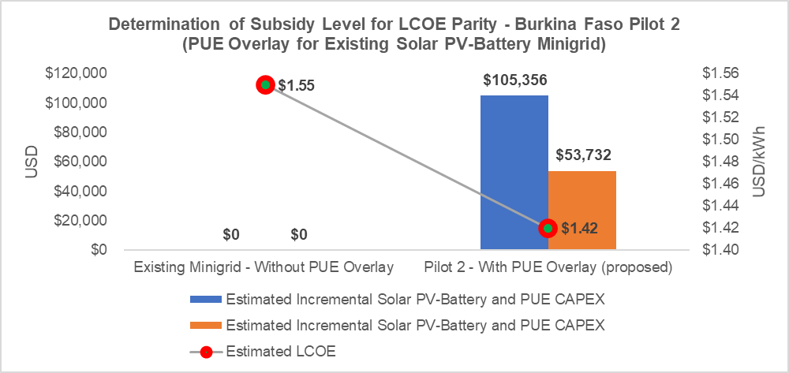

Step 3 – Estimating GHG ER for indicative minigrid system.

- The model estimates environmental benefits for the Solar PV-battery minigrid system by comparing the GHG emitted between the Program scenario (with PUE overlay of existing Solar PV-Battery minigrid system) and baseline scenario (without PUE overlay of existing Solar PV-Battery minigrid system).
- Estimation of GHG emissions avoided is based on estimating CO2 emissions reduction using emission factors for various consumer types as per AMS-III.BB: Electrification of Communities through grid extension or construction of new minigrids.
- The Figure below shows the GHG emission reductions due to deployment of PUE overlay of existing Solar PV-Battery Minigrid (Pilot 2 type) system. The proposed PUE overlay over this existing minigrid system will improve its capacity utilization factor and therefore also increase the lifetime carbon emission savings from this minigrid system. The modeling exercise of the existing indicative Solar PV-battery minigrid system estimated an annual carbon emission reduction of 90 tCO2e without PUE overlay and 118 tCO2e with PUE overlay, thereby achieving an effective GHG emission reduction of 28 tCO2e per annum for each of the 6.09 PUE Overlay pilots (Pilot 2 type). The modeling exercise also estimated a lifetime (20-year) carbon emission reduction of 1,802 tCO2e without PUE overlay and 2,357 tCO2e with PUE overlay, thereby achieving an effective GHG emission reduction of 555 tCO2e over a 20-year lifetime for each of the 6.09 PUE Overlay pilots (Pilot 2 type). For 6.09 such PUE overlay of existing solar PV battery minigrid systems, annual carbon emission reduction of 171 tCO2e and a lifetime (20-year) carbon emission reduction of 3,380 tCO2e when compared to baseline existing minigrid systems without PUE overlay. An increase in its lifetime carbon abatement costs (lifetime capex divided by lifetime carbon emission savings) from $91 without PUE to $123 with PUE overlay as the financial model does not assume economies of scale. The project yields an incremental GEF abatement cost of 32 USD/tCO2e.

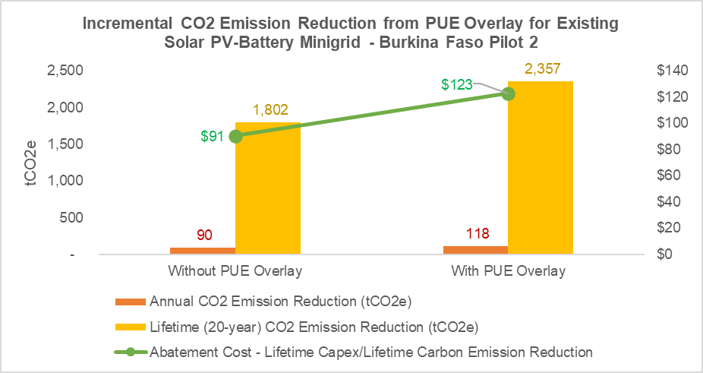
Figure 4: Incremental Annual and Lifetime CO2 Emission Reduction (tCO2e) with and without PUE Overlay for Existing Solar PV Minigrid – Burkina Faso Pilot 1

Inputs and assumptions.

Key inputs are summarized in the tables below:
- The following are the inputs used to determine system sizing (load profile of the customers, day-night usage split, capacity utilization factor and system oversizing requirement to compensate for yield degradation and internal electricity losses).

Input | Units | Values – Pilot 1 | Values – Pilot 2
Average daily consumption by customer segment/type
Residential | kWh / day | 0.27 | 0.27
Social | kWh / day | 1.2-2.4 | 2.70-4.32
Commercial | kWh / day | 0.51-1.08 | 0.51-1.08
Productive users | kWh / day | 10.32 | 6-36
Day/Night consumption Split
Day Time Electricity Consumption | % | 60% | 60%
Night Time Electricity Consumption | % | 40% | 40%
Connection of customers to the minigrid
% of total demand - Year 1 | % | 75% | 75%
% of total demand - Year 2 | % | 85% | 85%
% of total demand - Year 3 | % | 100% | 100%
Technical inputs
Solar Irradiation (kWh/m2) | kWh/m2 | 1850 | 1850
Solar Capacity Utilization Factor % | % | 21% | 21%
Seasonal Multiplier | - | 1.28 | 1.28
Usable Battery Energy % | % | 60% | 60%
Battery Oversizing % | % | 75% | 75%
Diesel Generators Power Factor | - | 0.8 | 0.8

- OPEX. The following are the inputs used to estimate the operational and maintenance costs (OPEX) for the minigrid systems analyzed.

Input | Units | Values – Both Pilots
RE Minigrid Operations & Maintenance (OPEX)
Annual Insurance Costs as % of Minigrid Capex | % upfront CAPEX | 2%
Annual O&M Costs as % of Minigrid Capex | % upfront CAPEX | 2%
Number of kWh per Liter of Fuel | kWh / Liter of diesel | 3.50
Fuel Cost Per Liter | US$ / Liter of diesel | 1.00

- CAPEX. The following are the inputs used to estimate the Capital expenditures (CAPEX) for the minigrid systems analyzed.

Burkina Faso Pilot 1.
Input | Units | Values – Pilot 1 Type (Greenfield Minigrid)
Minigrid CAPEX per Minigrid (Greenfield Minigrid – this CAPEX is proposed to be incrementally invested by this GEF project)
Solar PV + BoS + Inverter CAPEX (Energy Generation) | USD | 13,071
Battery CAPEX per kWh (Energy Storage) | USD | 26,241
Distribution Line CAPEX (Energy Distribution) | USD | 13,125
Site Development Costs | USD | 2,859
Other Costs - Transport, Installation, Soft Costs, Duties etc. | USD | 16,338
Total Minigrid CAPEX | USD | 71,634

Burkina Faso Pilot 2.
Input | Units | Values – Pilot 2 (Existing Minigrid) – without PUE Overlay | Values – Pilot 2 (Existing Minigrid) – with PUE Overlay
Minigrid CAPEX per Minigrid (Existing Minigrid – this CAPEX is only incrementally invested by this GEF project)
Solar PV + BoS + Inverter CAPEX (Energy Generation) | USD | 22,646 | 42,937
Battery CAPEX (Energy Storage) | USD | 45,464 | 86,202
Distribution Line CAPEX (Energy Distribution) | USD | 22,750 | 23,250
Site Development Costs | USD | 5,308 | 10,063
Other Costs - Transport, Installation, Soft Costs, Duties etc. | USD | 30,076 | 57,025
Total Minigrid CAPEX | USD | 126,244 | 219,477
Incremental Solar PV-Battery and PUE Overlay CAPEX (this CAPEX is proposed to be incrementally invested by this GEF project) | USD | 53,372 per minigrid pilot (6.09 pilots)

- Unit Costs. The following are the unit costs in terms of CAPEX per kWp of solar PV, CAPEX for kWh of battery, CAPEX per km of distribution lines etc. used to estimate the Capital expenditures (CAPEX) for the minigrid systems analyzed. These result in an average CAPEX per kW of installed capacity of $3,508 for Pilot 1 and $3,568 without PUE overlay and $3,271 with PUE Overlay.

Input | Units | Values – Pilot 1 (Greenfield Minigrid) | Values – Pilot 2 (Existing Minigrid) without PUE Overlay | Values – Pilot 2 (Existing Minigrid) with PUE Overlay
Minigrid Unit Costs
Solar PV CAPEX per kWp | USD | 640 | 640 | 640
Battery CAPEX per kWh | USD | 1285 | 1285 | 1285
Diesel Genset (Notional Baseline System) CAPEX per kW | USD | 375 | 375 | 375
Distribution Line CAPEX per kWp | USD | 643 | 643 | 347
Blended Transport + Installation Costs per kWp | USD | 800 | 850 | 850

- Capital Structure. The following are the inputs used to estimate the Weighted Average Cost of Capital (WACC) for the minigrid investments analyzed. The capital structure reflects a pre-derisking scenario in which debt is not readily available to finance minigrid investments and instead, minigrid investors have to finance projects with 100% Equity.

Input | Units | Values – Both Pilots
RE Minigrid Financial structure and costs
Equity % | % | 100%
Debt % | % | 0%
Cost of Equity % | % | 25%
Loan Tenor (Years) | Years | 8
Interest Rate % | % annual | 20%
Weighted Average Cost of Capital (WACC) | % annual | 25%

- GHG Emission factors. The model simulates a Solar battery Hybrid MG system, with or without the addition of a productive use of electricity (PUE) overlay, for three standard minigrid market sizes or for a custom sized minigrid market. Based on standard or customized demand metrics and typical average load profile of the customers, system size configuration is arrived at for each type of minigrid system.
- Estimation of GHG emissions avoided is based on UNFCCC methodology AMS-III.BB: Electrification of Communities through grid extension or construction of new minigrids.
- It is assumed that all consumers (Type I (household) and Type 2 (non-household) will have metered connections for simplicity reasons.
- Since both minigrid pilots supported under this project are off-grid where baseline energy is supplied by diesel or fuel oil or a similar fossil fuel, emission factor of baseline fossil fuel based energy generation is used.
- The main GHG emission reduction computation formula (as provided in the UNFCCC methodology) is:
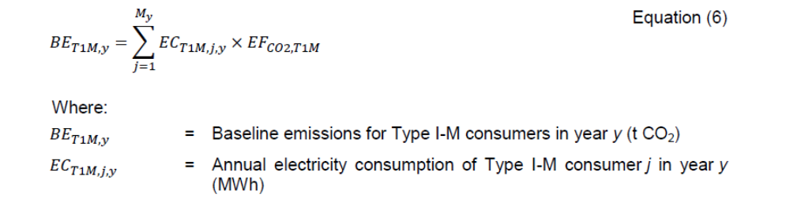
Baseline emissions of Type I-M consumers, BET1M,y are calculated as:
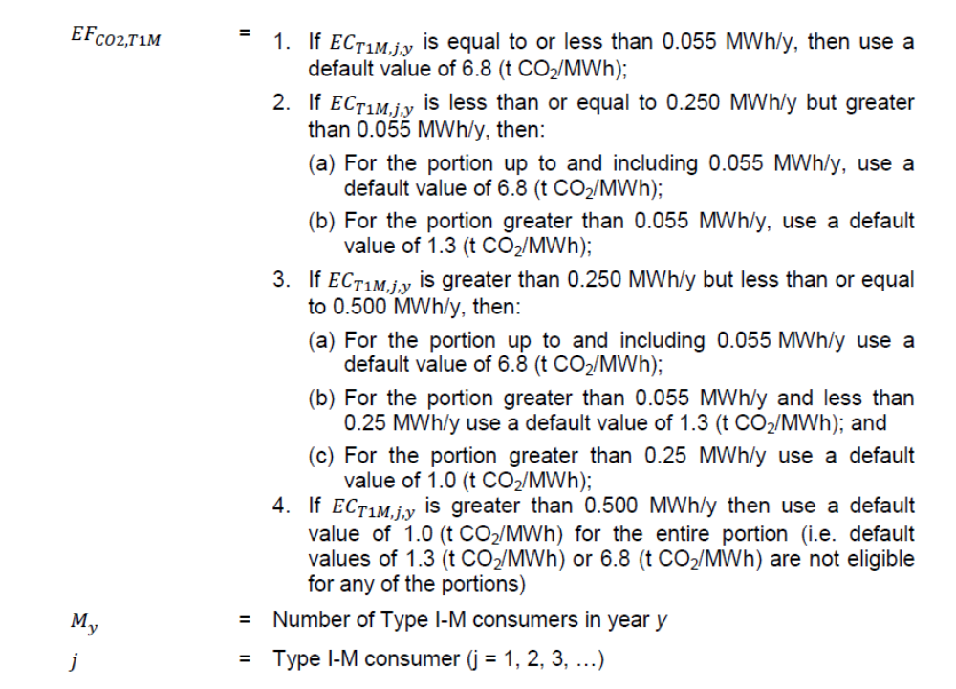
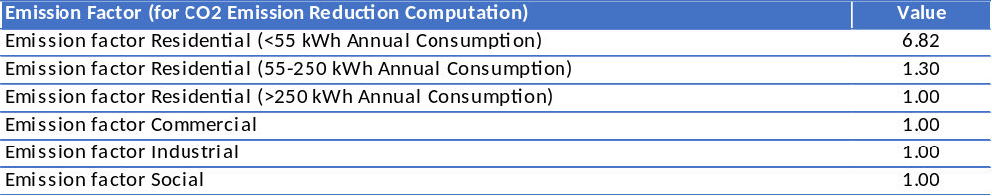
This formula is summarized in the table below:

GHG emission reduction estimation at PIF stage was made based on Capacity Utilization Factor (CUF), wherein amount of electricity units generated from the minigrid (using CUF of installed capacity) was multiplied with emission factors to arrive at GHG emission reduction estimates. The methodology used here is comparable to the one used during PIF stage, but it is more detailed due to the use of different emission factors for different types of customers (as required by the UNFCCC methodology).

The AMP national child projects provide capital cost subsidies, preset as a share of “reasonable” capital costs or based on lowest-subsidy bids, to provide direct financial support for one or more eligible minigrid operator(s) to: (i) develop minigrid projects, and/or (ii) purchase productive use appliances/electromechanical equipment to be leased to and used by minigrid customers.
The price that would have to be paid for each unit of electricity output (e.g kWh) to cover total costs of electricity supply (including capital investments, operating costs, and financing costs) over the lifetime of the system.
All documents approved by the GEF on its December 2019 Council.
10% of the indirect GHG ER of this an all AMP national child projects have been removed from each project and allocated to the AMP regional child project, in line with the apportioning of the overall program budget and reflected in the PFD allocation of GHG emissions reductions across the different child projects. This reflects the benefits of national child projects accessing the regional child project’s support which is expected to contribute and enhance the enabling conditions required for minigrids development across AMP countries.
10% of the indirect GHG ER of this an all AMP national child projects have been removed from each project and allocated to the AMP regional child project, in line with the apportioning of the overall program budget and reflected in the PFD allocation of GHG emissions reductions across the different child projects. This reflects the benefits of national child projects accessing the regional child project’s support which is expected to contribute and enhance the enabling conditions required for minigrids development across AMP countries.
https://cdm.unfccc.int/methodologies/DB/TI8KFU0GX1JBYZLOIJ6OMCSVYXCZUJ
https://cdm.unfccc.int/methodologies/DB/TI8KFU0GX1JBYZLOIJ6OMCSVYXCZUJ
https://cdm.unfccc.int/methodologies/DB/TI8KFU0GX1JBYZLOIJ6OMCSVYXCZUJ

